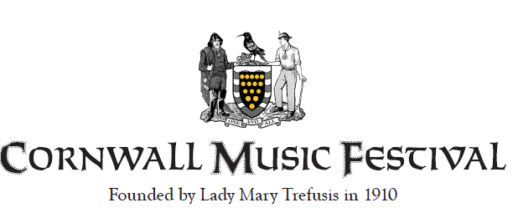
Please complete this form and return it to:-

Elizabeth Willis 53, Bosvean Gardens, Truro. TR1 3NQ

EITHER..….Join the Friends Scheme 2022 – 2023
The FRIENDS SCHEME is ideal for families. The set donation entitles an individual, couple or family (max 4) to a free programme and free admission to every event during the Festival week, including the Gala Concert – especially useful when a number of children in the same family are taking part in a number of events. The Festival benefits from the guaranteed income. Please choose as appropriate:
- I would like to renew my Friends Membership fee for the year January 2022 – 2023
Name |  | Type of Membership | Tick chosen level | Cost
Address |  | Single |  | £25.00
 |  | Couple |  | £40.00
 |  | Family |  | £50.00
Postcode
Email
Tel No

- I would like to become a Friend of the Cornwall Music Festival for the year January 2022 – 2023
Name |  | Type of Membership | Tick chosen level | Cost
Address |  | Single |  | £25.00
 |  | Couple |  | £40.00
 |  | Family |  | £50.00
Postcode
Email
Tel No

OR… Become a Subscriber 2022 - 2023
The SUBSCRIBER SCHEME has no official lower limit to the donation, though a minimum of £10 per year is suggested. If you are a UK taxpayer, the Festival can considerably increase the benefit of your subscription by the use of Gift Aid. (If you wish to become a subscriber, a Gift Aid Form will be posted to you on receipt of this form)
£
I would like to subscribe (enter amount) to The Cornwall Music Festival for the year January 2022 – 2023
Name (s)
Address Line 1
Line 2
Town
County
Postcode
Email address
Telephone No.
Cheques (made payable to The Cornwall Music Festival) should be posted to:-
Elizabeth Willis 53, Bosvean Gardens, Truro. TR1 3NQ

All other payments should be made online to
HSBC, Sort Code: 40-44-34, Account: Cornwall Music Festival, Account No: 61766473

The Festival would like to extend its sincere thanks for your support.

